* 1. Overview of Equity Trading System illustrating Dodd Frank Flow

Equity Trading is a trading and risk management application developed in-house by GFX IT development for the business areas trading Equity options. It is a core transaction processing system for Equity options trading.

It is inhouse application, developed for Traders. It is used for Pricing, risk and position management, trade entry and options lifecycle for Equity options. It also generates multiple batch reports like Customer Report for sales, Risk management reports for traders and Trade Detail & valuation report for downstream system.

Equity Trading is a client/server application, with all computations being performed on NT servers for pricing and risk management of trades. In reality it is like a suite of utilities that surround the main client server application which captures pricing and trading information. Equity Trading performs all end-of-day option valuation.

All the information captured in the system is replicated real time in the database based in Singapore and London. It is a place where the trades are persisted, Deal # is generated, and the trades get processed. Equity Trading is used internally and is not exposed to the clients. It handles cash and options trading. There are many products supported by Equity Trading are Vanilla Options, Barrier Options (Knock In, Knock Out etc.), P/O (Pay-out), Digital, Bet, Gated options, Vol/Var, Accruals, FVA, Window Products, etc.

**Starting the application:**

When we launch the application from the Start ->Programs, the below drop down is displayed.

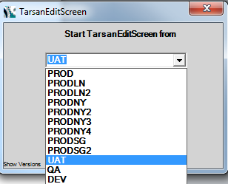

We can select from the dropdown which environment /server we want to connect to and click on Start button

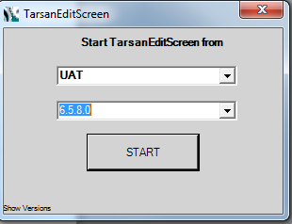

The application launches itself and the below screen is opened up.

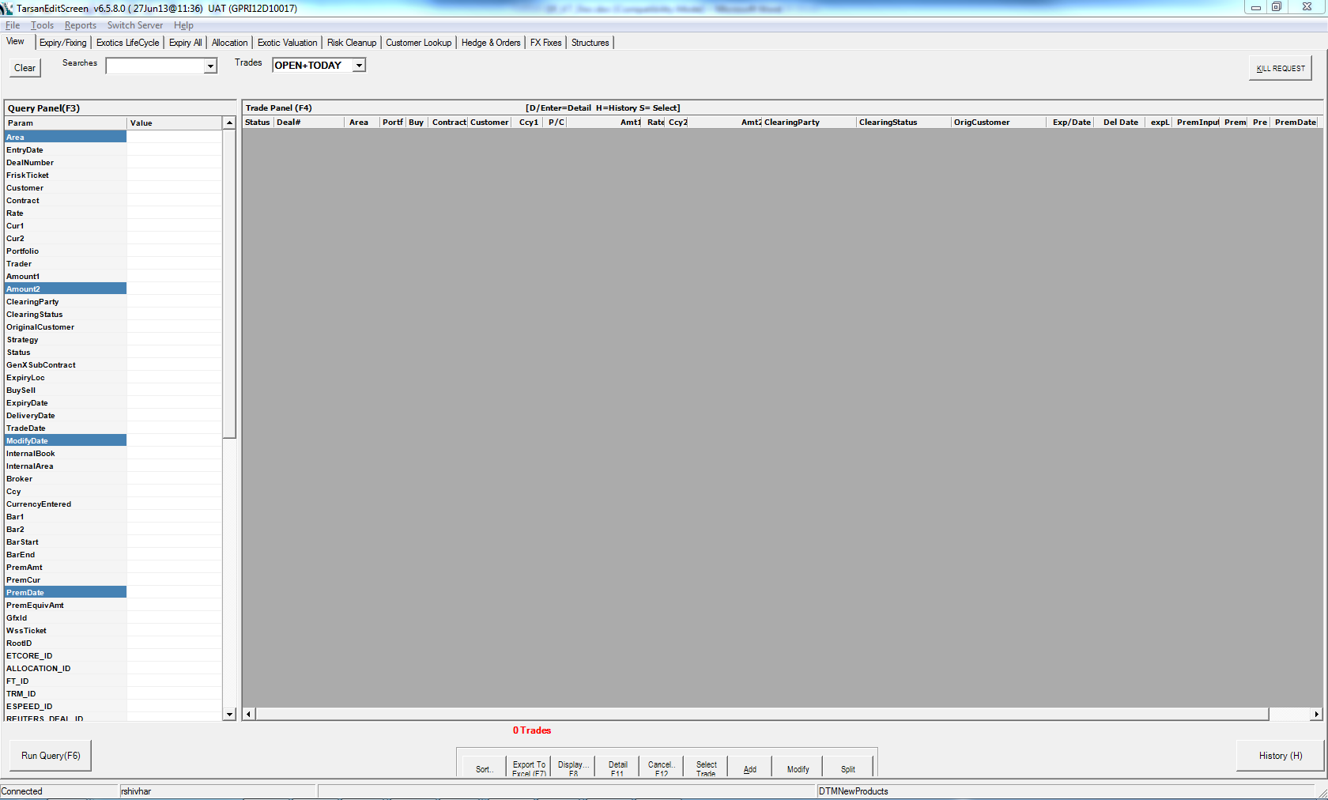

Then,Click on ADD button and select Vanilla as product ,following screen will get opened up,

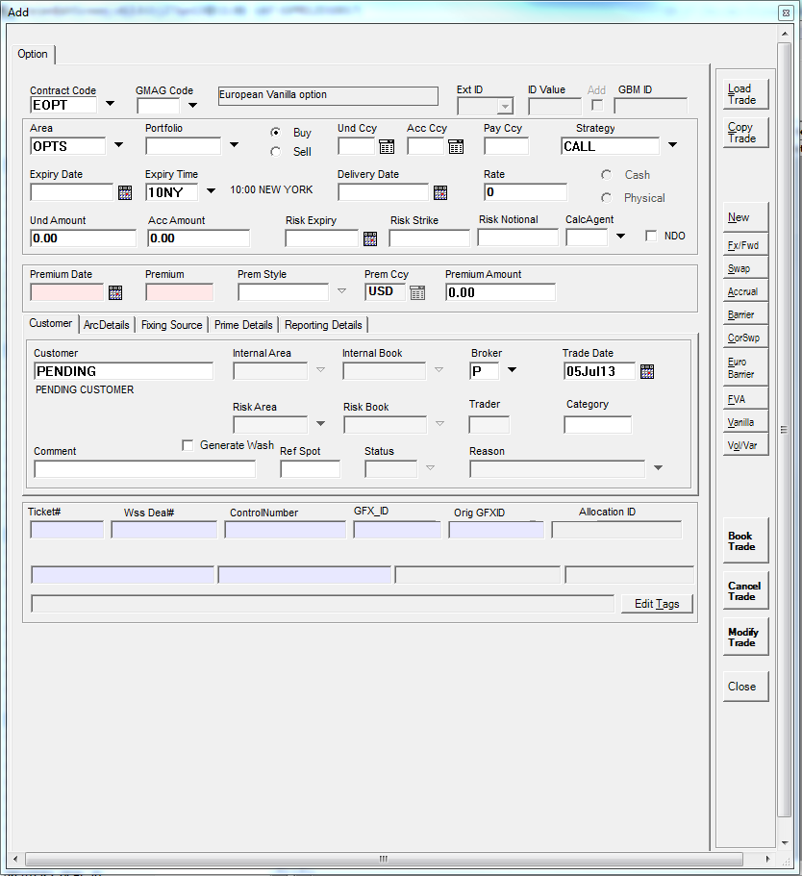

Booked trade appear in the panel as below:

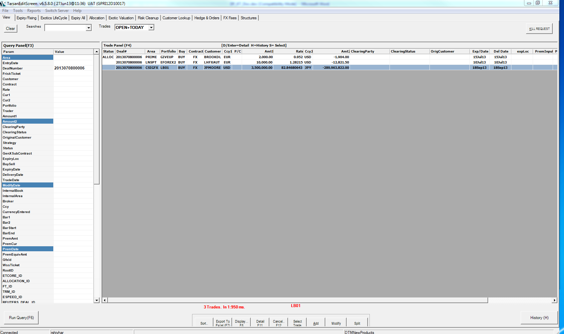

Then amend the trade amount ,and then cancel,

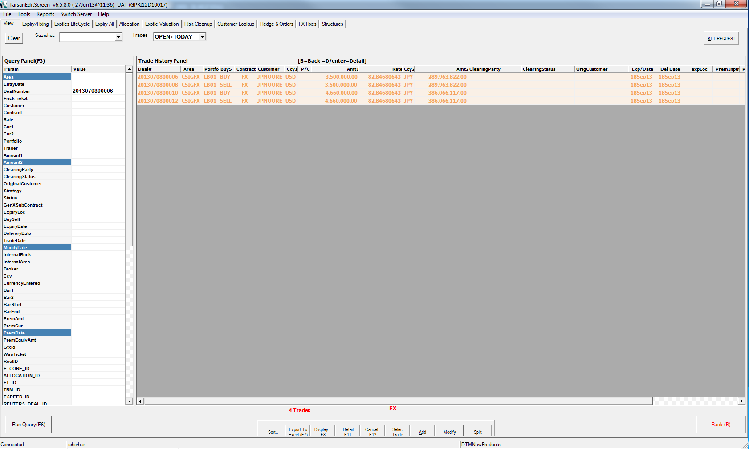

Afterwards,book an EOPT trade ,and then exercise it ,as follows ,

In expiry fixing tab ,set the test data you have used to book the trade and search your booked trade to exercise it ,

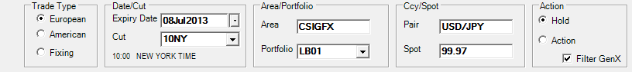

Some trades will be listed out ,search your trade by sorting according to frisk id of the trade, then exercise it ,below is the screen shot for the same ,

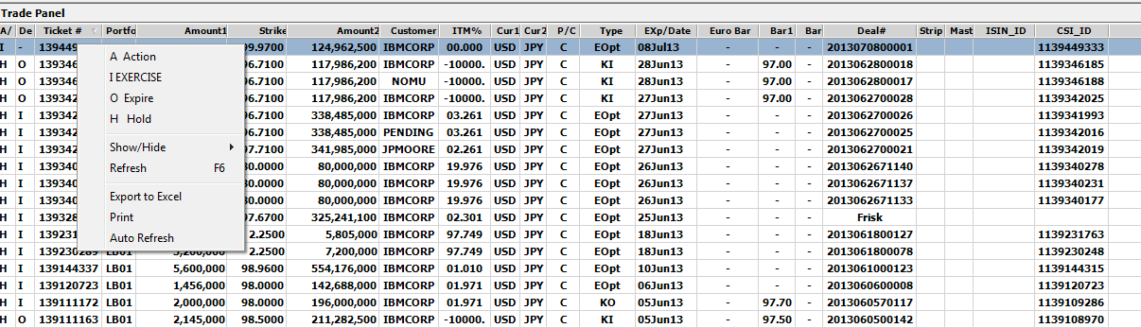

After selecting exercise trade,process and confirm the trade and go back to View tab,and check history of the booked trade.

Block Diagram of Equity Trading application with an enhancement:

Booking and Life Cycling

CRRE

SDR Adaptor

GTR/DTCC

Equity Trading /WSS

FXOPS

Lightning

Manual

CLS

GTR/DTCC

**Reporting Confirmation**

Equity Trading Trade Processing System consists of the following components:

* **Equity Trading:** A GUI used by Traders to enter/book trades. A tool called Merlin is also there, which is used for this purpose. Then there is a whole risk engine that runs to validate and process the data and to generate appropriate reports. This application was originally called Equity Trading GUI.
* **Booking and Life Cycling of Trades:** Once a Trade is booked, through any of the application, it has to be life cycled then. After life cycling gets completed, all the reference IDs are taken and then further verifications are performed.
* **CRRE:** CRRE i.e.. Central Regulatory reporting Engine is an audit tool where with the help of WSS ticket of the parent trade, details like Report ability in CRRE, Reporting party, Reporting type, Reporting obligation party etc.. are being checked and verified.
* **FXOPS:** It is the main back office system for trade settlement. Three types of confirmation are being performed here.
* Lightning Confirmation: It’s an independent team which receives trades for FXOPS for Paper confirmation.
* Manual Confirmation: Here FXOPs itself decides whether to confirm trade or not, we have to explicitly ask to confirm the booked trades. For trades which are not going to be confirmed by FXOPS, Equity Trading should send an auto-confirmation for these trades.
* CLS: Zurich based application, which is completely handled by Clearance System for confirmation purpose.
* **SDR Adaptor:** Swap Data Repository, which acts as an intermediate between CRRE and GTR, once CRRE gets acknowledgement it is then sent downstream to GTR.
* **DTCC/GTR:** Global Trade Repository used for reporting confirmation. All the trade transactions are reported here.
  1. Behaviour of various Products in CREE for different Life Cycling event’s :

|  |  |  |  |  |
| --- | --- | --- | --- | --- |
| **S:NO** | **Life Cycling Event Type** | **CRRE Reported** | **Reporting Type** | |
| **1** | New/Amend | Yes | | RT-PET |
| **2** | Exercising | Yes | | PET |
| **3** | Expire | Yes | | PET |
| **4** | Cancel | Yes | | PET |
| **5** | KI/KO | NO | | Unknown |
| **6** | FIX/UNFIX | NO | | Unknown |

There is one more tab in CRRE, Reporting Party whose output completely depends on the type of customer you have used for a particular branch.

Below, is an example with screen shots which illustrates a trade flow booked through TES.

Three trades will be available there ,original booked trade,Backout trade and one exercised trade ,With the help of control Id of original trade ,verify all the Reporting status of trades in CRRE as follows ,

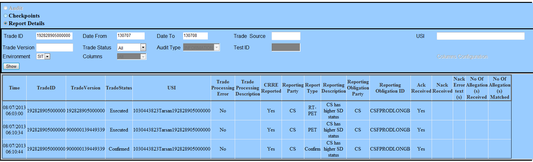

As it is an EOPT exercised trade,all the fields if we see in CREE should be as follows ,

CRRE Reported : YES

Reporting Party :CS

Reporting Type :RT-PET /PET for Base and Exercised trades respectively .

Ack Received :YES

And as in the screen above ,all the fields are as expected,hence it worked fine till now.

Next ,will move to SDR for FXOPS Status Messages and status ,

**List of Equity Trading Products:**

1. **AOpt:** American Option: Put or Call vanilla option that may be exercised early.
2. **Bet:** One Touch Bet that pays off in pay currency if barrier1 is hit before expiry. Strategy is Up (pays if spot rises above barrier) or Down (pays if spot drops below barrier). Payment is received on delivery date.
3. **DBet:** Double One Touch Bet. Bet that pays in pay currency if either barrier1 or barrier2 is hit before expiry, i.e if spot does not remain between barrier1 and barrier2.
4. **DgKI:** Digital Knockin Option: Knockin option, that pays off in flat amount of pay currency if spot is above strike at and strategy is Call, or if spot is below strike at expiry and strategy is Put.
5. **DgKO:** Digital Knockout Option: Knockout option, that pays off in flat amount of pay currency if spot is above strike at and strategy is Call, or if spot is below strike at expiry and strategy is Put.
6. **DgRKI:** Digital Reverse Knockin Option: Reverse Knockin option, that pays off in flat amount of pay currency if spot is above strike at and strategy is Call, or if spot is below strike at expiry and strategy is Put.
7. **DgRKO:** Digital Reverse Knockout Option: Reverse Knockout option, that pays off in flat amount of pay currency if spot is above strike at and strategy is Call, or if spot is below strike at expiry and strategy is Put.
8. **DIG:** Digital option that pays off in pay currency if spot is above barrier1 at expiry and strategy is Up, or if spot is below barrier1 at expiry and strategy is Down.
9. **DKI:** Double Knockin Barrier option that knocks in (converts to a European option) if barrier1 or barrier2 is hit before expiry. Expires worthless if neither barrier is hit.
10. **DKO:** Double Knockout Barrier option that knocks out (becomes worthless) if either barrier1 or barrier2 is hit before expiry. If neither barrier is hit, pays off like a European option at expiry.
11. **EOpt:** European Vanilla option. Has value at expiry if strategy is Call and spot > strike, or if strategy is Put and spot < strike.
12. **EXO:** Place holder for European Vanilla option. Used for LBO1 washbook trading.
13. **FX:** Forward Deal. Exchanges currency2 for currency1 at delivery, independent of spot rate.
14. **Inst:** Instant One Touch Bet that pays off in pay currency if barrier1 is hit before expiry. Strategy is Up( pays if spot rises above barrier ) or Down ( pays if spot drops below barrier ). If contract triggers payment is received on current spot date.
15. **InKO:** Instant One Touch Bet with Knockout. Pays in pay currency if barrier1 is hit before expiry, but knockouts if barrier2 is hit before barrier1 is triggered. If contract triggers payment is received on current spot date.
16. **KI:** Knockin barrier option that knocks in ( converts to a European option ) if barrier1 is hit before expiry. Expires worthless if barrier is not hit. The barrier is hit as the option is decreasing in intrinsic value ( as spot drops for a Call , or rises for a Put ). For a Call , barrier < strike and for a Put, barrier > strike.
17. **KO:** Knockout barrier option that knocks out ( expires worthless ) if barrier1 is hit before expiry. Pays off as a European option if barrier is not hit before expiry. The barrier is hit as the option is decreasing in intrinsic value ( as spot drops for a Call , or rises for a Put ). For a Call , barrier < strike and for a Put, barrier > strike.
18. **NT:** No Touch Bet that pays in pay currency if barrier1 is not hit before expiry. If strategy is Up, spot must stay below barrier ( barrier is not hit as spot goes up ). If strategy is down, spot must stay above barrier ( barrier is not hit as spot goes down.)
19. **OTKO:** One Touch Bet with Knockout. Pays in pay currency if barrier1 is hit before expiry, but knockouts if barrier2 is hit before barrier1 is triggered. Payment is received on delivery date.
20. **RB:** Range Binary. Bet that pays in pay currency if neither barrier1 nor barrier2 is hit before expiry, i.e if spot remains between barrier1 and barrier2.
21. **RKI:** Reverse Knockin Barrier option that knocks in (converts to a European option ) if barrier1 is hit before expiry. Expires worthless if barrier is not hit. The barrier is hit as the option is increasing in intrinsic value ( as spot rises for a Call , or drops for a Put ), so barrier > strike for a Call and barrier < strike for a Put.
22. **RK0:** Reverse Knockout Barrier option that knocks out ( expires worthless )if barrier1 is hit before expiry. Pays off as a European Option if barrier1 is not hit. The barrier is hit as the option is increasing in intrinsic value ( as spot rises for a all , or drops for a Put ), so barrier > strike for a Call and barrier < strike for a Put.
23. **WKO:** Window Knockout option: Same as KO , but knocks out only if barrier is breached within some window of time, defined by a barrier start and barrier end date.
24. **WRKO:** Window Reverse Knockout option: Same as RKO , but knocks out only if barrier is breached within some window of time, defined by a barrier start and barrier end date.
25. **WDKO:** Window Double Knockout option: Same as DKO , but knocks out only if barrier is breached within some window of time, defined by a barrier start and barrier end date.
26. **WKI:** Window Knockin option: Same as KI , but knocks in only if barrier is breached within some window of time, defined by a barrier start and barrier end date.
27. **WRKI:** Window Reverse Knockin option: Same as RKI , but knocks in only if barrier is breached within some window of time, defined by a barrier start and barrier end date.
28. **WDKI:** Window Double Knockin option: Same as DKI , but knocks in only if barrier is breached within some window of time, defined by a barrier start and barrier end date.
29. **Window Barriers:** Window barriers can already be traded in Equity Trading. The difference between an ordinary barrier and a window barrier is that an ordinary barrier can be triggered anytime between the trade date and the expiry date, while a window barrier has a specific start and end date for the barrier (or barriers). If the trigger is breached before the start date or after the end date, the barrier is not triggered. If it is breached during the window, the barrier is triggered. The functionality for window barriers that is being added to Equity Trading is to allow the trader to specify two separate windows for the two barriers in a double barrier. The trader will be able to specify a start and end date for the lower barrier and a different start and end date for the upper barrier. Note - the trader may also have one barrier for the life of the option and the other barrier in a specific window. (The default values for both barriers will be the 'trade date' as the 'start date' and the 'expiry date' as the 'end date'.)
30. **Gated Barriers:** GKO, GRKO, GDKO, PGDKO: A gated barrier is a type of knockout option that converts into a vanilla option with a portion of the original notional when a barrier is breached. The option can be a single or double knockout. If it is a single KO, the only barrier is a gated barrier. If it is a double KO, the user has a choice between having both barriers gated or having one of the barriers gated and one ordinary. If the ordinary barrier is breached, the option knocks out completely. If the gated barrier is breached, the option is exercised into a vanilla option with the notional calculated as: original notional * (number of days passed from start of option / total number of days of option). The days calculated can be calendar days or business days. In the first release, only calendar days will be a valid selection. It is possible to have a gated window barrier where there is a specific window during which the gated barrier could be breached. For a gated window barrier, the notional of the vanilla option is calculated as: original notional * (number of days passed from start of window / total number of days of window)
31. **Gated No Touch:** A 'gated no touch' is to a 'no touch' as a 'gated barrier' is to a 'barrier'. (Dust off those old SAT prep books to figure that one out.) Basically, if any no touch barrier is gated, when the barrier is breached, it exercises into a payment with the amount calculated based on the rules for the gated barriers.
32. **Volatility and Variance Swaps**: VolSw, VarSw: Volatility and variance swaps are similar instruments. The difference between them is whether the underlying is the volatility rate or the variance, which is the square of the volatility. The trader specifies a fixed volatility rate (or variance) and that is swapped for the realized volatility throughout the life of the swap. There is no upfront premium and no choice of exercising or not. At expiry, a payment is made by either the buyer or seller. The payment is calculated as: difference between the fixed volatility and the floating volatility * the contract principal. There will be a number of parameters in the confirmation that will specify the rules regarding how the realized volatility is calculated.
33. **Accrual Option: AccO , RAccO:** An accrual option is an option with a specified notional that is adjusted at exercise time, based on the number of fixings within a specified range. There will be a fixing schedule specified (this can only be a regular schedule in the first phase) and the final notional will be calculated as: original notional * (number of fixings where the condition is met / total number of fixings) If the accrual type is 'above' or 'below', there is only one barrier and the fixings where spot is above or below that barrier are the ones where the condition are met. If the accrual type is 'inside' or 'outside', there are two barriers and he fixings where spot is between (inside) or outside those barriers are the ones where the condition are met. There will be parameters on the confirmation to specify details that can be translated into a fixing schedule. These include Accrue Tenor, Accrue Date Adjuster, First Accrue Date, First Regular Accrue Date, Last Regular Accrue Date and Last Accrue Date. The business is looking into the rules regarding when a barrier is touched but not breached – is it considered inside or outside and above or below.
34. **Accrual Payment:** AccP. RAccP: An accrual payment is similar to an accrual option except that the notional that is being accrued is the notional of a payment instead of the notional of an option. The final notional will be calculated at exercise and a payment will generated instead of applying the notional to a vanilla option.